Assignment 3 Report

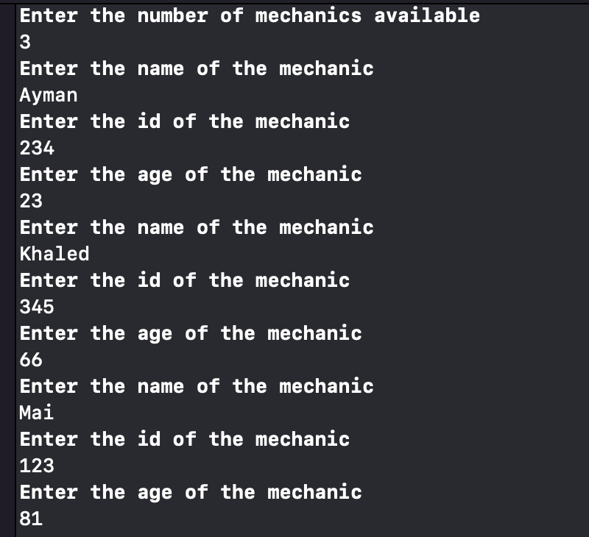

Here I’m asking the user to input the information about the mechanics. The information is the number of mechanics, their names, ages and ids.

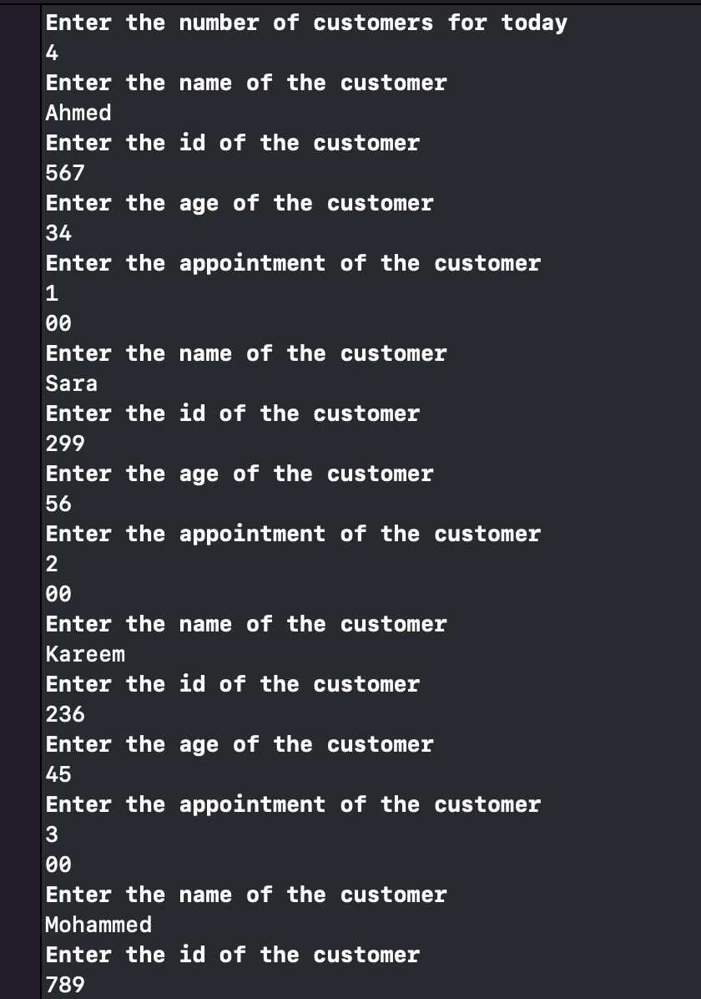

Here I’m asking the user to input the number of customers for the day and to enter their details. The details are their names, age, id and the appointment time they want.

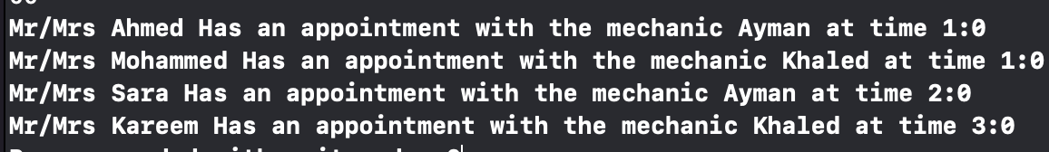

It’s the output for which customer gets which mechanic and at what time.

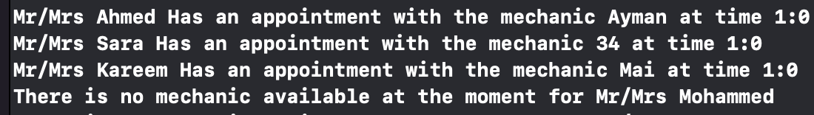

This is when there are multiple customers who want the same time but not enough mechanics.